NEW YORK 2000
(or THE MARATHON THAT WAS)

A mild bout with the flu the week before notwithstanding, I was standing along with some 30,000 eager participants in the crisp morning air on Verazzano bridge, awaiting the gun at 10:50 signaling the official start of the 31st running of the famous New York Marathon on November 5, 2000. Long preparation, turns and twists of events, uncertainties and fears preceded the run, but ultimately here I was, nervous, but ready, to submit my body and psyche to the grueling 26.2 miles that would both try and exhilarate all participants.

I had already had an aborted attempt at this run last year when due to the death of one of our monastic brothers I was notified the morning of my departure that I would not be able to participate. That unsuccessful try prompted me to collect my thoughts and write the story that I entitled “The Marathon That Wasn’t.” All along, I had hoped that the essay would not be the last word, and it wasn’t; here I am again, organizing my memories to forge them into a more pleasant story that would become part my running history.

Long before the run itself, even before the start of the earnest preparation, some unusual events kept popping up that merit elaboration. Knowing that I had automatic acceptance to this year’s marathon, (it was due to my sending in the cancellation within the deadline last year) the checking of the Internet database was not nearly as exciting as previously. But, even with the assurance on the part of the organizers in New York, I was not yet assured permission from my superiors in the monastery, so my periodic checking of the web site still contained a certain amount of wishful thinking that would be changed to certainty only later. It was with a flush of excitement that I first noticed next to my name the magic word “accepted.” I kept going back to the site on a regular basis, just to satisfy my sense of anticipation and checking for names of people I knew were planning to run, when to my great surprise I found one day that there was another fellow named Bernard Marton who was accepted. The stats provided by the net are rather skimpy, but I learned that the individual is 56 years old and hails from Champigneulles, France. Given the rather unique Hungarian quality of the spelling of my name I felt a sense of mission that I had to find out everything I possible could about my “relative.” The first step, naturally, was an e-mail to the organizers of the race. Within a short time, I received the expected answer that they could not release any specific information about the participants—but would forward a letter if I sent the hard copy to them. I immediately composed my letter (see attachment #1), and mailed it off to New York. Within a very short time response came back to me in a letter that looked almost spooky: it was addressed to me, all right, but on the back, the return address also, naturally, was my name. (see attachments #2 and #3). My namesake also found the similarity eerie and decided to pursue the issue, providing me with an address and phone number in New York. Thus, my trip took on an added interest.

From the beginning my preparation suffered a setback: I had had shoulder surgery for the removal of some bone spurs in my right shoulder in early June, and while it may not seem that sore shoulder ought to hinder running, my training for the November run did not proceed as smoothly as I had wanted or expected. I favored my right side, started to make awkward adjustments in my stride, and, most importantly, I slowed my pace markedly. Soon I fell behind schedule in my longer runs and was really unable to catch up completely. I also took a vacation to visit my family in Hungary, and the carrying of my luggage with the newly repaired arm did not help much. My practice runs were also somewhat reduced, although I did manage to run a half-marathon in Balatonalmádi on July 22nd that produced less than sterling time results (one of my worst half-marathon time of 2:10:23). Returning home I tried to catch up and did my best I could. Still, I had only one what could be considered a long run, an 18 miler three weeks before the race. The time was slow, and I knew it. But there was nothing I could do at this late stage of the game, except hope that my lack of preparation would not come back to bite me. One thing though, perhaps the most important, had been taken care of: my superiors have given me the green light for the New York trip. It was to be like last year, the combination of college visits and the marathon. I started to make preparations to arrange for appointments at Columbia and Fordham Universities.

I searched the net for the cheapest airfare and found a Delta flight round trip for $249.00; I pounced on it. Had I waited another week I could have taken a special for $50 less, but my ticket was one of those “no change, no refund” so I had to hold onto that one. It was still a very good deal. I did not have to worry about my stay since my old friends, the Reinemunds, were going to be my hosts. What I did not know early on, not only would they host me at their home, but I would become an official member of the Team PepsciCo, receiving also an official, embroidered jacket, and passes for all events, both prior and post marathon activities. The jacket would become my favorite piece of clothing, equally for running and non-running activities, and I would gladly wear it on the way to school, even inside the class. Naturally, the logos would elicit some remarks or questions, and I would gladly answer them.

I kept a much lower profile, and did not broadcast my plans as I did last year. Only my most closely connected friends knew what was on my mind. Flu season came a bit early, and I also encountered it early. On Tuesday, the week before the marathon I woke up in the middle of the night with a very sore throat and aching muscles: typical symptoms of the malady. Since I was already in the tapering-off phase of my preparation, I was not too worried about missing some runs, but still the illness bothered me. I very seldom get sick, and I am not a good patient; I absolutely loathe to have to accept help from another, but this time I had to call in sick on Thursday, thus missing my classes. I had moderately recuperated, except for a deep cough, by Friday, and I went to a class outing with my boys to the downtown YMCA. Some parents who helped me with the supervision expressed concern about my resolve to run the following week. I had also received some e-mail from others, urging me to cut out the full course, and run the ½ marathon that was organized for the same weekend at White Rock Lake. Having come thus far, with so much energy spent, I hoped and prayed—and decided that come hell or high water, I would run the New York Marathon on November 5th.

Only high water came. I could hardly believe the downpour after four months of drought (with 112 degree weather on Labor Day) we were experiencing just as my departure neared. My plane was scheduled to depart at 7:30 a.m. on November 3rd. By now I was a routine traveler, having drawn on past running experiences, and did show up in plenty of time. That plenty of time became even more as our flight was delayed by the weather. In spite of it all, an eventless 4 hours later we touched down at New York’s La Guardia airport. The upcoming event was clearly in sight and the preparations were visible everywhere. Steve’s secretary, Ann Cusano, had arranged for my pick up and I was immediately taken to the new home of the Reinemunds in Greenwich. Gail’s mom, Bette, greeted me with her wonderful, warm smile, and told me that the twins would be back with their mother very soon. By four in the afternoon, they were back and we were on our way to Pepsi headquarters in Purchase for big league pep-rally. I was introduced to my team-mates who came literally from all over the world, and we all in turn, were presented to the general employees who gave us a rousing welcome. I did not realize the quality of competitors I stood next to, but knowing the type of people Steve likes to work with, I was not really surprised to see their names very high in final result tally. After the pep-rally, we were all invited for dinner to the Reinemunds that was to last until about 10 p.m. That same evening, Gail’s sister, Bev and her husband stopped by on their way home to New Jersey, and we had a short, but wonderful visit. I was ready to retire for the night in Stephen’s room. I had a good night’s sleep.

I was supposed to be at Columbia by 10 on Saturday morning. The trip went without a hitch; I met with the people I was scheduled to meet and, as I have now accustomed to experience, also ran into some folks I knew: the great aunt Kevin Resnick (a junior at Cistercian), and Michelle Morgan from Colleyville, a good friend of one of our teachers. This habit of running into people has become the hallmark of this trip. At noon, I was supposed to meet Steve at Pier 94 to pick up our packets. We had exchanged cell-phone numbers the night before and it became very useful since Steve got stuck in traffic and could not make our appointment. I was waiting for him at the entrance, and with my jacket must have looked so official that three or four people walked up to me asking for direction about the race. It was at this venue that I realized just how enormously large the run would be, and just what logistical nightmare the organizers had to work themselves through. Steve arrived, forgot his official papers to obtain his number, but resolved the issue without great difficulty. We browsed around in the enormous hall, ordered some souvenirs then took off for our apartment at the corner of 59th Street and Columbus Circle. That address did not mean much to me at first, but it did have a familiar ring to it: The Trump International Hotel. Yes, the same man of international renown. PepsiCo had an apartment for its VIP’s on the 32nd floor. Following the advice of many running experts we took a short, three mile run on the back end of the course, then went off to the second part of the official activities and dinner at the ESPNZone Skybox Room. While there, I met another Pepsi runner who is based in Hungary, spoke the language, and actually worked in the same district of the city I grew up in. Again, small world. I left early, for I had an appointment with the other Bernard Marton. I really did not know what to expect.

The cab weaved in and out of traffic, but quickly found its way to the Hotel New Yorker between the 34th and 35th street. I paid the fare and stepped into the lobby. I asked the concierge for Bernard Marton and fully expected the answer that indeed came: we don’t have anyone by that name. Since I always had difficulty in convincing people that I spelled my name M a r t O n, without blinking an eye I requested the proper spelling. “Oh, yes, here is his room, talk to him.” By then he had already come down to the lobby to await me, so I asked his roommate what he looked like. I was told that he was of slight built and wore blue pants and blue warm up jacket. The description was of little help, but I went on my search. I posed to the first person that fit the description the proverbial parlez vous français question, and was not even surprised to hear him respond affirmatively. I then proceeded with my statement/question that he must then be my French/Hungarian namesake. He indeed was. With a torrent of French, he ushered me upstairs where we could sit quietly and obtain answers to our questions. He was rather convinced that we were related. I was not so sure. He told me about an uncle of his who disappeared in the campaign to the eastern front during World War I; for him that meant Hungary. He also showed me the picture of his now deceased father, who ironically had the same name as my baptismal name, George, and talked about his family. He invited me to visit him in France. That I promised I would do when opportunity presented itself. Upon my departure, he gave me a big hug, kissed both my cheeks in the French style, and was convinced that he had just discovered a hitherto unknown Hungarian/American kin. We decided that we should continue to look into our genealogies.

Upon my return to the hotel, all I wanted to do was to rest. I had already prepared my running gear for the morning: black, long-sleeved Asics jersey under my official Pepsi shirt with the #33199 firmly attached to the front, black compression and running pants, my new socks from Cynthia Lastimosa, my Asics Marco running shoes, and a pair of black gloves. This combination would make me look very cool. I quickly went to bed, but, as it normally happens before marathons, sleep escaped me for quite a while. The crisp morning came rather soon. Steve and I left for the PepsiCo sponsored bus at shortly after 7. The first phase, the waiting, of the marathon had begun.

As the bus rolled slowly toward out destination, Staten Island, we spent the time aboard by small talk and swapping war stories. Most of the participants were veteran racers, thus the descriptions of various races became more and more interesting. My seatmate across the isle, Dave Damrath, was not only a seasoned marathoner, but also a frequent participant in the Ironman races, and swim marathons. I was absolutely amazed to hear how one actually approaches a swim that will keep him in the water for up to sixteen hours. Another participant was asked how often he has swum the English Channel: his response was, twice—this year. Among my teammates was also John Paul Reisches, a wheelchair participant, who would come in second among his fellow contestants. I was also told what to expect, some useful information, some of which merely interesting or funny. I recalled that one of the ladies warned me not be offended if we saw a number of men relieving themselves off the bridge. I stored all the information as my anticipation slowly began to reach its peak.

We arrived to the starting place and the bus disgorged its passengers. Almost immediately, we all got lost in the crowds, which were enormous. I now began to see what a throng of thirty thousand runners looked like. I was looking for my staging area, the 33 to 34,000 numbers, and had already made a few wrong turns when I accidentally bumped into my friend Dave Damrath. I was happy to see him since he really had an air about him that he knew everything. And he almost did. With his help, I soon found my location and also the UPS truck that would transport our packages back to the finish line. Since our group was part of the PepsiCo team, we all received a small, pink sticker that we were to affix to our bibs, indicating our “celebrity” status. What it provided was swift deposit and equally quick retrieval of our belongings once we finished. We stood in line for what seemed like forever in front of a Port-O-Let facility; then I lost Dave. I was now completely alone, on my own.

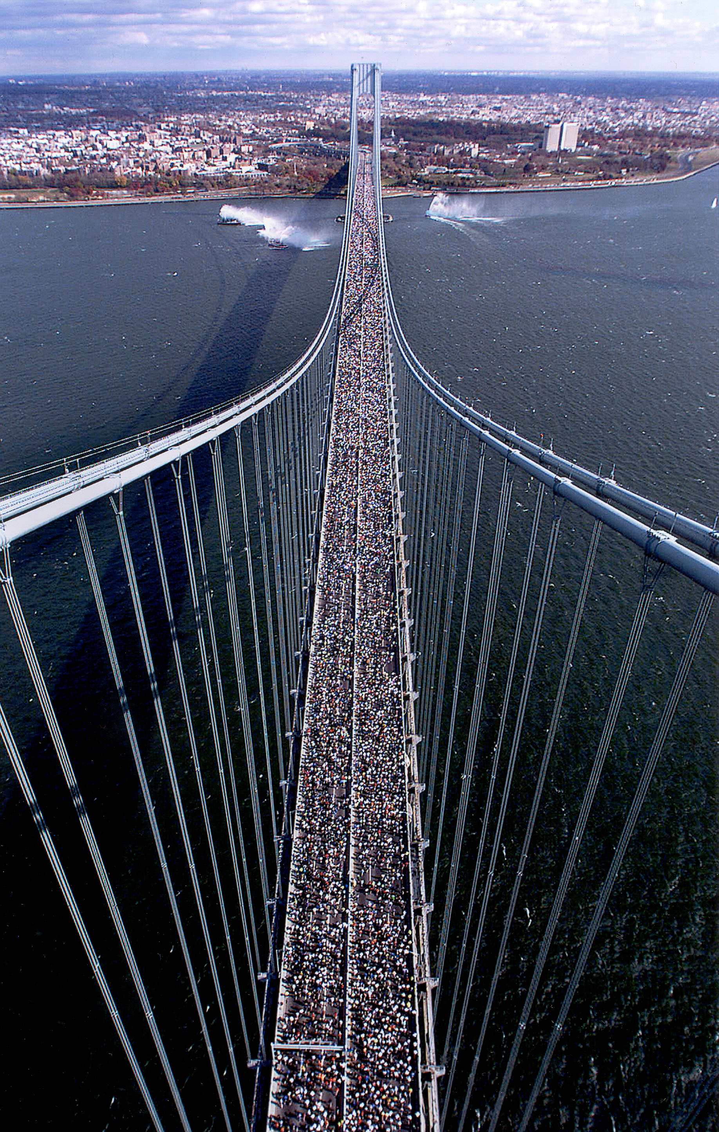
Once in a marathon, however, one is never alone. The folks are so friendly, they are so willing to talk and exchange stories that within minutes I was talking with a man from the Bronx, of approximately the same age as myself, as we started to line ourselves up in front of the Red Exit. It must have been about 10:30. Very soon, I began to notice some unusual happenings that apparently were of normal occurrence at the New York Marathon. A tree, with its bare branches reaching toward the sky, suddenly began to sprout strange limbs: first a sweatshirt, then some pants, then some other items of clothing. The time for the start must have been very close, for people began to shed their extra clothes that they brought along to fight the cold, and were now stripping themselves to their running gear. The throng in front of me began to move, so I also started to walk. Off to my left I saw a woman in full bridal dress, including a veil, who was hopping and hurrying toward the front. Later I learned that she got married at the 17th milepost, having met her husband-to-be at a previous marathon. We slowly moved to the bridge. Next to me, there were all sorts of people from all sorts of places. Some old lady told me that this was her 18th marathon. Another one was from Texas, who used to live in Irving, yet some others in front of me were from Italy, while the folks behind me were from England. From their speech, it was obvious where they were from. The helicopters were already hovering overhead when we all heard two very loud booms: the race was under way.

More than likely I must have lined up at the wrong starting station since within a couple of minutes after the official start we all began to run. I expected a much longer walking period, but I did not complain. What I wish that a well-placed complaint could have solved was the strong north wind that was nearly blowing us off the Verazzano Bridge. But here we were, we were running in the New York Marathon. We could not have been more than half-way through the bridge when I saw what the lady on the bus was warning me about: a great number of men were relieving themselves off the side of bridge. Proper hydration is always strongly advised, but what to do with the residue of the water consumption is usually not discussed. When nature calls and you got to go, you just got to go. One had to be careful in this strong wind, and it was advisable to steer toward the sheltered side of the roadway in order to avoid the mist. At first I thought that only men would dare to relieve themselves in this fashion, but soon I found that women too, although not in the same large number, were much in the same boat, and they also lined up alongside the men. What was interesting, though, was the fact that everyone took it so naturally, including the spectators, and there was no gawking or snickering.

The course continued and meandered through the various boroughs. They all had something special about them, either the neighborhood or the spectators lining the streets. First only sparsely, then more and more densely, the whole route was one big party: bands, solos, boom-boxes, fire-trucks, national symbols and emblems all began to emerge with one purpose in mind, to encourage the runners and offer them support in a variety of languages. A very interesting scene unfolded itself in Brooklyn Heights, as we entered the Hasidic Jewish neighborhood. Little children, all dressed in uniforms, along with their mothers, lined the streets, and you could also see the fathers, with long side-curls also shouting encouragement. The whole neighborhood seemed like a foreign country, for all the inscriptions and writing were done in Hebrew letters. I wished I could have slowed down a bit to savor this flavor, but I was running already slowly enough; I did not want to stop. I settled into my slow routine, along with a number of other runners. There was a Norwegian woman dressed as a Viking who elicited many comments. Mother-daughter, sister-brother teams ran together. For miles I followed a man whose calves were inscribed with indelible ink the symbol for “I love Dawn” and “I love Hannah.” At about mile six I came upon a pair of women conversing in what seemed to me rather strongly accented English. As is my custom when encountering friendly looking strangers I asked where they were from. It should not have surprised me to hear the lady say that she was from Hungary. However, it was now her turn to be indeed surprised hearing me responding back to her in Hungarian. She told me that originally she was from Hungary, but for the time being she lived in Mexico City, and she was running with another Mexican friend. After a water station we parted company, but later on I was able to find her name in the database (Falusi Julianna), and also found that she finished the race in very close to five hours.

Some outfits were outrageous, like animal costumes, other just mildly interesting, resorting mostly to funny hats and inscriptions. I saw a good number of people with the Texas state flag running shorts. I knew they had to be from home. Shortly after the ten-mile marker I came upon a lady wearing the same Texas shorts with Luke’s Locker inscription on her back, who looked like she could use some encouragement. I inched up to her, patted her on the back and said something about “Great going Luke’s Locker” or something of this nature. She gratefully turned toward me and said that my simple greeting pumped her up and was sufficient for her to continue the run, for she was ready to give up. As we ran together, and we would do so for nearly the rest of the marathon, she told me that she was incredibly tired. She also revealed the reason for her exhaustion: just two weeks ago she had run the Chicago Marathon. Foolhardy, I say, but now I was ready to pull her on. Our conversation became a welcome distraction; my insertion of one-minute walks after nine minutes of running offered her respite. I learned that she was from Lewisville, was 39 years old and that people were encouraging her by yelling “Way to go, Renee!” so I presumed that her name was just that. After mile 24 she complained that if she walked her knee would lock up, so I told her not to slow down for me. She promised that she would wait for me at the finish. We never saw each other. After many searches on the web, using the information she provided, plus our split-times together, I was able to find out her full name and that she was from Highland Village. I wrote her a letter (attachment #4) and gave it to my friends at Luke’s Locker for mailing. I am awaiting a word from her, for I know she will react.
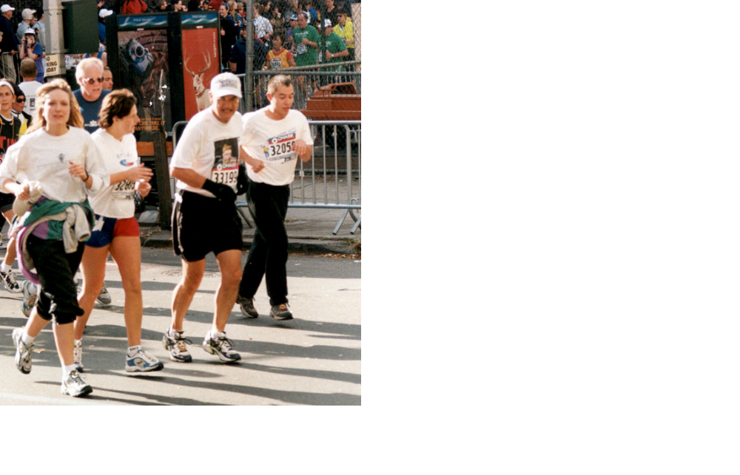

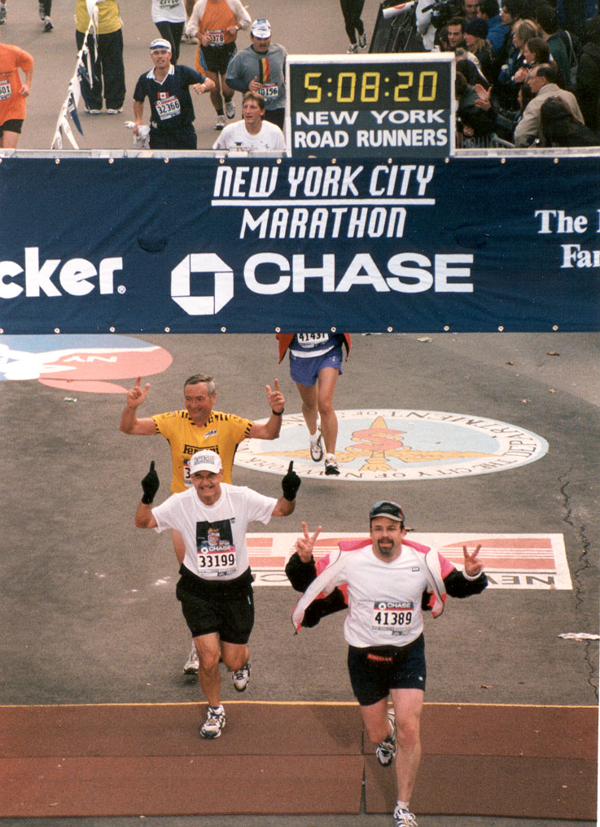
When we turned into Central Park where we could see Columbus Circle and the statue in the distance I knew that my ordeal would soon be over. The crowds grew thicker and louder. Since I had on my jersey the picture of a Frito-Lay package they called me the “chip man.” They also continued to yell out the much used “You’re looking good” slogan to which I had to reply at least once, although smiling as much as I could muster: “You are lying.” I know I did not look good, for I felt pretty miserable. My walk breaks came more frequently, and the last uphill stretch really wore me out. But I had to put on a smile for the camera at mile 25 since I ordered a custom made video of Steve and myself; I had to look good. Mercifully the end finally came. I held up both arms in victory as I officially crossed the finish line in 5 hours 8 minutes and 20 seconds, for I was a victor. As I received my finisher’s medal the well-earned sensation of accomplishment filled me with satisfaction.

I walked back to the hotel where Steve was nearly ready to leave for Johannesburg, South Africa. We bade each other good-bye. I took a good soaking in a hot bath, then awaited my friends, the Ewings, who came up from Greenwich to take me out for dinner. I had a huge porterhouse steak that I could not finish. I had the leftovers for breakfast. The next morning I called my family back in Hungary and my Form Master of old, Károly Munkácsy, and informed them of my exploits. I then met with John Erdman, our graduate from last year’s senior class, in front of Fordham University’s Lincoln Center campus. We had a great visit, and then I headed back, still glowing, wearing my official marathon jacket to Dallas.
Attachment #1 (original in French)

Susan Cipollone
9 East 89th Street
New York, NY 10128

Dear Runner, Irving, October 10, 2000

I was surprised to see your name—my name—on the list of participants in the New York marathon on November 5, 200

What astonished me was the exact duplication, first and last names, especially since I am from Budapest, and the name Marton, without the accent (so it is not Márton) is really Hungarian. There is not another person that I know of, neither here in the US nor in Europe, except those in Hungary. Are you perhaps Hungarian yourself?

Whatever the case may be, I would love to meet you in New York. I am older than you are, so I presume also slower. My point of departure is at the red concourse. In case you wish to respond I’m sending you my address here in Texas:

Bernard Marton
One Cistercian Road
Irving, Texas 75039

I also have an e-mail address, Bmarton@cistercian.org

By the way, I am a Cistercian monk, living in the our Abbey of Our Lady of Dallas, a runner for four years. I am the former headmaster, presently a full time teacher, of our preparatory school by the name of Cistercian Prep. I have already finished three marathons, but only here in Fort Worth, the Cowtown Marathon.

Hoping to receive word from you, I am sending you, dear sir, the expression of my most sincere sentiments.
Attachment #2 (original in French)

Champigneulles, October 10, 2000

Bernard Marton
3, Fontaine Saint-Joseph
54250 Champigneulles, France
Tel.: 03-83-38-03-21

Dear Mr. Marton

I am following up on your letter that I have received today. Reading through it I was surprised to find that I have a namesake in America.

I would indeed, with great pleasure, wish to meet with you while visiting New York. Herewith I append the address of my hotel where I shall be spending my days from November 1 through the November 8, 2000: New York Hotel
481 Central Avenue
34th & 35th Street
Tel: (219) 971-0101

The coincidences are at times unbelievable. Last August I received a letter from the Clouet publishing house, I am herewith attaching a copy, regarding an artist by the name of MARTON, of Hungarian origins, a painter and poster-maker in the ‘20’s. Perhaps you might be able to provide some information about our origins.

Expecting to meet and to talk about ourselves, please accept, dear sir, the expression of my most sincere sentiments.
Attachment #3 (original in French)

29, rue Docteur Brulet
21120 IS-SUR-TILLE – FRANCE

03.80.95.33.00
Fax 03.80.95.02.36
aclouet@clouet.com

Sender: Elodie GARNIER Destination: Mr. & Mrs. MARTON Date: August 2, 2000

Sir, Madame,

We have been publishers for 14 years, and we specialize in the reproduction of old posters and postcards on the topic of advertisement and tourism in the ‘30’s and reproduce – among other things—advertisements for PEUGEOT since the beginning of the last century. We have just recently discovered the artist MARTON, of Hungarian origins, who was a painter and poster-maker in the 1920’s.

We would like to reproduce the works of M. MARTON with the permission of his heirs, unfortunately, we have not been able to find them.

That is why we are asking you the question: is this artist part of your immediate or removed parentage?

Thanking you in advance for your precious response,

Sincere salutations,

Elodie GARNIER
Archivist

CLOUET PUBLISHERS

Attachment #4

Saturday, November 11, 2000

Dear Angela (?) Renae (?), Angela R; running partner,

Having fully recovered from last Sunday’s ordeal I have searched my mind for any kind of information that might lead me to you so that I might thank you properly for the support you have given me during our 10+ mile run together. There were four specific things I remembered: you trained with Luke’s Locker in Dallas, you were 39 years old, you ran the Chicago Marathon two weeks ago, and people lining the course yelled encouragements to you as Renae, that you always acknowledged with a kind “Thank you.” I was very sorry that we got separated, and that I could not at least thank you for your support and companionship. I even forgot to ask your name or bib number.

I did more research on the web and, comparing our ½ marathon times I figured that whoever showed up owning the same time I did, must be you. The only person that resembled you was a certain Angela R Lorentz from Texas. I wasn’t quite sure. Then I searched the Chicago results where you showed up as Renae Lorentz from Highland Village, TX. Armed now with a full name and location I approached the good folks at Luke’s Locker to forward my mail to you. I have absolutely no ulterior motives in contacting you except to thank you again, and let you know that I immensely enjoyed our conversation during the run. The distraction our chatting provided certainly helped in conquering the last few miles. I apologize for slowing you down, but I was running very low on gas.

In a few words let me tell you who I am and what I am doing. I am a priest, a monk, belonging to the Cistercian Order (you may have noticed on my cap the embroidered “Cistercian Preparatory School” logo.) and I used to be the Headmaster of our school for fifteen years. Presently, after having retired from my post, I am a full time teacher at the same school, teaching French and Latin, and also serve as Director of College Counseling for our Seniors.

I had a great time in New York, visited some friends (my former students and their parents), Columbia and Fordham Universities; my accommodations at the Trump International Hotel were absolutely superb. Like you, I came home on Monday, began teaching immediately the next day. As I mentioned, I have fully recovered and have no residual side effects of the exertion. I am in the process of writing down my thoughts and reflections on the race. In case you are interested, and are willing to let me know how to contact you, I shall forward you a copy also.

Hoping that you also had a restful week, I wish you the very best.

Fr. Bernard Marton, O.Cist.
Director of College Counseling

THE PROOF

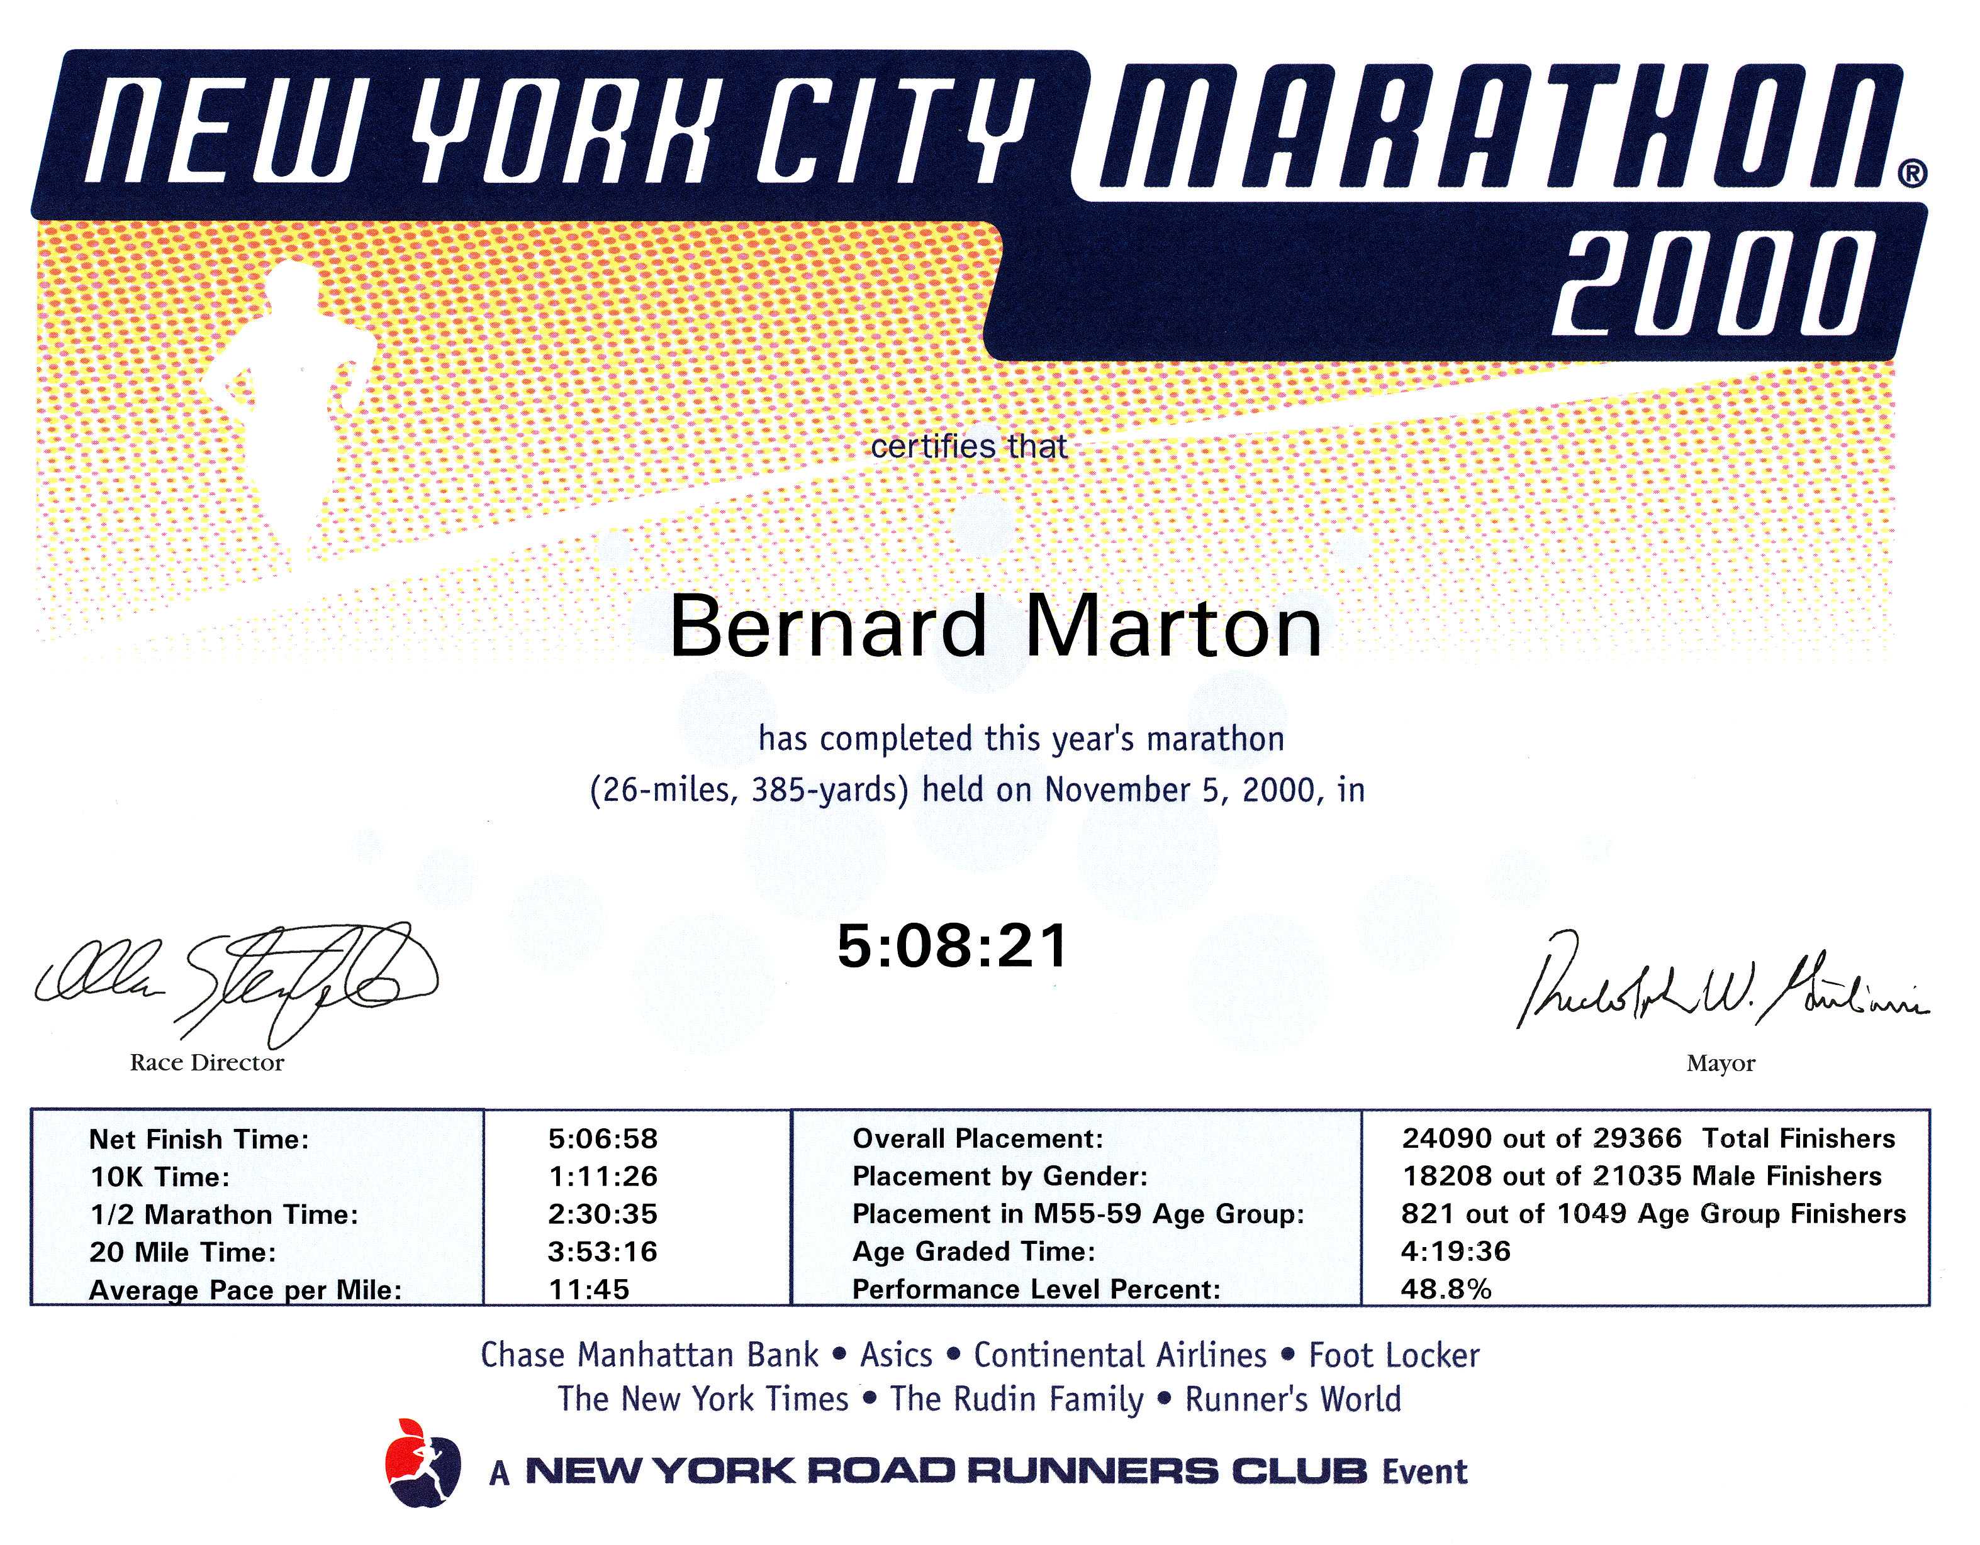

V o i l à !

